|  |  |  |
| --- | --- | --- |
| SCHOOL OF INFORMATION AND TECHNOLOGY | | |
| NAME: Caccam, Jesus Allyson O | DATE PERFORMED: Aug. 22, 2024 | 50/50 |
| Section: IDC2 | DATE SUBMITTED: |

# SYSADM1 – Introduction to File Systems in Windows and Linux

# Requirement:

* A virtual machine running Linux and Windows OS

# Instructions:

**Part A: Windows File System**

1. **Open File Explorer:** Click the File Explorer icon on your desktop or press the Windows key + E.
2. **Navigate to your Documents folder:** This is usually the default location for user files.
3. **Create a new folder:** Right-click in an empty space, select "New," then "Folder." Name it "Lab1_Windows."
4. **Create a text file:** Right-click in the "Lab1_Windows" folder, select "New," then "Text Document." Rename it to "info.txt."
5. **Open the text file:** Double-click the "info.txt" file to open it in Notepad.
6. **Type some text:** Write a short paragraph about yourself or the purpose of the file.
7. **Save the file:** Close the Notepad window and save the changes.
8. **Create a subfolder:** Create a new folder inside "Lab1_Windows" called "Data."
9. **Copy the text file:** Copy the "info.txt" file to the "Data" subfolder.
10. **Rename the copied file:** Rename the copied file to "data.txt.
11. Create a folder named "LabFiles" with subfolders for each file type. Use the internet for the resources of the files listed below.   
      
    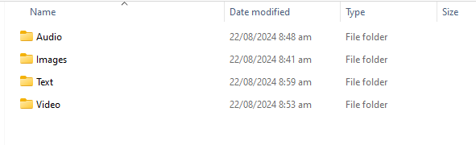

**LabFiles**

* 1. **Text**
     1. large_text.txt
     2. small_text.txt
     3. code.cpp

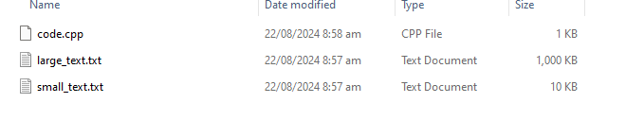

* 1. **Images**
     1. image1.jpg
     2. image2.png
     3. image3.bmp

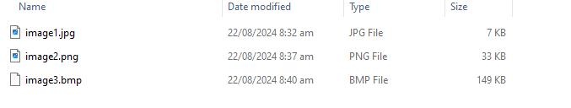

* 1. **Audio**
     1. song.mp3
     2. speech.wav

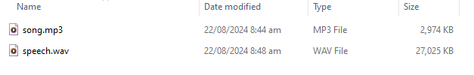

* 1. **Video**
     1. clip.mp4

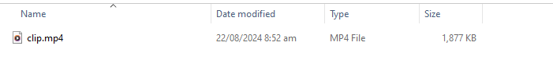

1. **Check file properties:** Right-click on the "info.txt" file and select "Properties." Explore the General, Details, and Security tabs to understand file attributes like creation date, size, and read-only status.

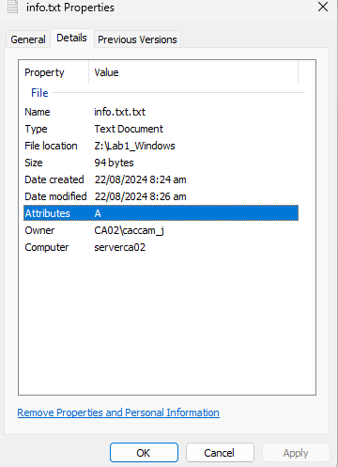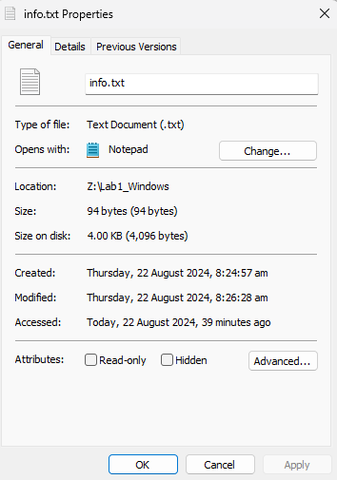

1. **Change file attributes:** Try changing the file attributes (e.g., read-only, hidden) using the Properties dialog. Observe the changes in File Explorer.

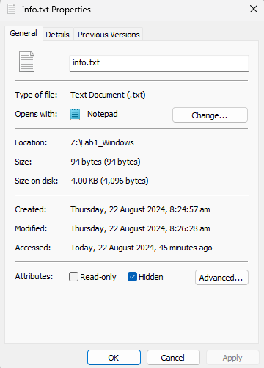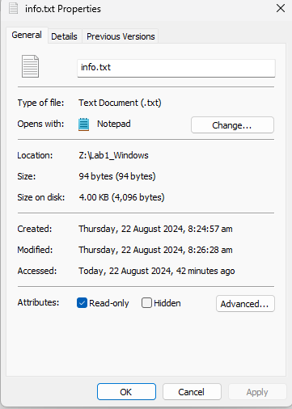

1. **Share the folder:** Right-click on the "Lab1_Windows" folder, select "Properties," and then the "Sharing" tab. Share the folder with a specific user or group, setting appropriate permissions (e.g., Read, Write, Full control)
2. **Create an archive:** Use WinRAR or 7-Zip to create a compressed archive of the "Lab1_Windows" folder.
3. **Extract an archive:** Create a new folder, then extract the created archive into it.

Part B. Create a log report structure

|  |  |  |  |  |
| --- | --- | --- | --- | --- |
|  |  | Report Log Structure |  |  |
| Date | Task | Description | Status | Remarks/Notes |
| 08/22/2024 | 1 | Open File Explorer | Complete | Opened the file explorer |
| 08/22/2024 | 2 | Navigate document folder | Complete | Navigated the document folder through the drive Z. |
| 08/22/2024 | 3 | Create a new folder named “Lab1_Windows” | Complete | Created a new folder in the |
| 08/22/2024 | 4 | Create a text file named “info” | Complete | Created a text. |
| 08/22/2024 | 5 | Open the text file | Complete | Opened the text file and write some text on it. |
| 08/22/2024 | 6 | Type some sample text like paragraph about yourself | Complete | Opened the text file and write some text on it. |
| 08/22/2024 | 7 | Save the file | Complete | File saved |
| 08/22/2024 | 8 | Create a subfolder named “Data” | Complete | Created a new folder or new subfolder. |
| 08/22/2024 | 9 | Copy the text file from the “Lab1_Windows folder” and place it in the “Data Folder” | Complete | Copied the text file. |
| 08/22/2024 | 10 | Rename the copied file into “data.txt” | Complete | Renamed the text file |
| 08/22/2024 | 11 | Create a folder named “Labfiles” | Complete | Created a new folder |
| 08/22/2024 | 12 | Download 2 text files and 1 cpp file | Complete | Download files for the folder |
| 08/22/2024 | 13 | Download 3 images,(jpeg, png, and bmp) | Complete | Download images for the folder |
| 08/22/2024 | 14 | Download 2 audios (mp3 and wav) | Complete | Download audio files |
| 08/22/2024 | 15 | Download a mp4 video clip | Complete | Download video file |
| 08/22/2024 | 16 | Check file properties | Complete | File checked properly |
| 08/22/2024 | 17 | Change file attributes | Complete | File attributes checker properly |
| 08/22/2024 | 18 | Share the folder | Incomplete | Cannot share because there is no share tab |
| 08/22/2024 | 19 | Create an archive | Complete | Archive folder |
| 08/22/2024 | 20 | Extract an archive | Complete | Successful extraction. |

|  |  |  |  |  |
| --- | --- | --- | --- | --- |
| Date | Problems Encountered | Task number | Description | Notes/Remarks |
| 08/22/2024 | Folder cannot share | 18 | Share folder | The folder properties doesn’t have a sharing tab. Thus, sharing cannot be done. |